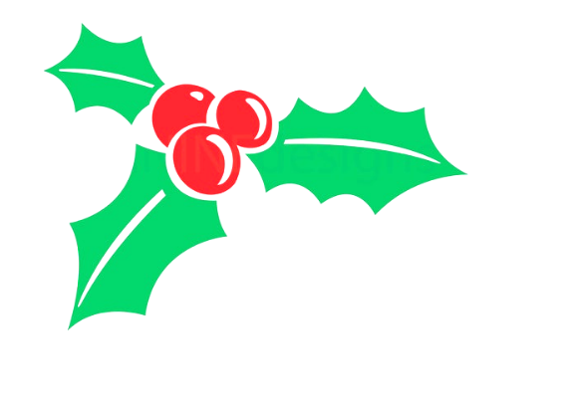
PROGRAMM

Canticum Novum | Ivo Antagini
O Rex Gentium | Matthew Martin
O Radix Jesse | Rihards Dubra
Praise the Lord | Daniel Knaggs
Morning Star | Arvo Pärt
O Salutaris Hostia | Jacob Narverud
Ave Verum Corpus | Ben Parry
Let My Love Be Heard | Jake Runestad
Alleluia | Jake Runestad
Day of Fire and Sun | Dominick DiOrio
Stars | Ēriks Ešenvalds
Autumn Landscapes  Sügismaastikud  1. Üle taeva jooksevad pilved  2. Tuul kõnnumaa kohal  3. Kanarbi | Veljo Tormis
Pūt, vējiņi | Imant Raminsh
How I Long | George Montagu
Mo Ghile Mear | Arr. Desmond Early
Wild Mountain Thyme | Arr. Eoin Conway & Desmond Early
Dúlamán | Michael McGlynn
Swept Away | Sarah Quartel

